SIMATS ENGINEERING
CO2 - ASSESSMENT TOOL 2
Scenario-Based Questions
COURSE NAME: Deep Learning COURSE CODE: MLA0408

COURSE OUTCOME COVERED
CO 2: Students will be able to apply supervised learning algorithms such as linear regression, classification models, decision trees, neural networks, support vector machines, and ensemble methods to solve real-world prediction and classification problems. They will gain the ability to select appropriate models, train them using datasets, and evaluate their performance. Students will also understand the strengths and limitations of different supervised learning approaches. (BTL-4)
CO Weightage: 15%
Assessment Tool Weightage: 40%
Duration: 90 minutes

Marks: 25

Code of Conduct:
I vemula saiteja (Name / Reg No) certify that this submission is my original work and that I have adhered to the guidelines specified for this assessment.
I understand that any violation of academic integrity rules will result in disciplinary action.
Signature of the student:

Scenario-Based Questions
CO-AT2
QUESTIONS: 05 Total Marks:25

Unsupervised Training of Neural Networks, Auto Encoders
A hospital wants to identify abnormal ECG patterns from thousands of unlabeled records. Which deep learning technique from the syllabus would you recommend? Justify your choice and explain the workflow.

Auto Encoders, Representation Learning
A retail company wants to reduce the dimensionality of customer purchase data before performing customer segmentation. Explain how an autoencoder can be used to solve this problem.

Width and Depth of Neural Networks, Activation Functions
A facial recognition system performs poorly when trained using a shallow neural network. Recommend architectural changes involving network depth and activation functions.

Restricted Boltzmann Machines (RBMs), Unsupervised Training of Neural Networks
A streaming service wants to recommend movies to users based on their viewing history without using labeled data. Explain how RBMs can be applied to build the recommendation engine.

Deep Learning Applications, Representation Learning
A manufacturing company wants to detect defective products from sensor readings collected every second. Design a deep learning solution using concepts from representation learning and neural networks.
RUBRICS FOR CALCULATION:
Criteria | Weightage | Level 4 –  Exemplary | Level 3 –  Proficient | Level 2 –  Developing | Level 1 –  Beginning
Concept  Identification | 25% | Identifies all key concepts from literature accurately and comprehensively | Identifies most key concepts with minor omissions | Identifies limited concepts; some are irrelevant or missing | Fails to identify essential concepts
Linkages | 25% | Establishes clear, meaningful, and accurate relationships between concepts | Shows correct relationships with minor gaps | Relationships are weak, unclear, or partially incorrect | No meaningful relationships established

Organization | 20% | Concepts are wellstructured hierarchically with logical flow and grouping | Mostly organized with minor structural issues | Some  organization but lacks clear hierarchy | No logical organization or structure
Integration of  Literature | 20% | Integrates multiple studies effectively to show connections and comparisons | Shows some  integration of literature | Limited integration; mostly isolated concepts | No  integration of literature evidence
Clarity | 10% | Concept map is clear, neat, visually structured, and easy to interpret | Generally clear with minor readability issues | Clarity is reduced; difficult to interpret in parts | Poorly presented and hard to understand

1. Unsupervised Training of Neural Networks, Auto Encoders
Answer:
For identifying abnormal ECG patterns from thousands of unlabeled records, the most suitable deep learning technique is an Autoencoder. An autoencoder is an unsupervised neural network that learns the normal characteristics of ECG signals without requiring labeled data. Since labeling medical data is expensive and time-consuming, autoencoders are highly effective for anomaly detection.
The autoencoder consists of three parts:
- Encoder: Compresses the ECG signal into a lower-dimensional representation.
- Latent Space (Bottleneck): Stores the most important features of the ECG signal.
- Decoder: Reconstructs the original ECG signal from the compressed representation.
During training, the model learns to reconstruct normal ECG patterns accurately. When an abnormal ECG signal is provided, the reconstruction error becomes significantly higher because the model has not learned abnormal patterns.
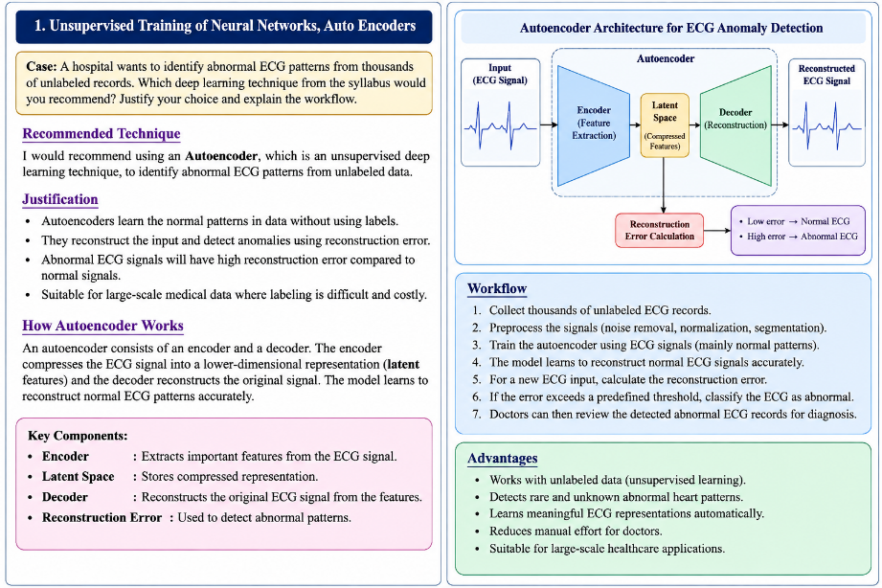
Workflow:
- Collect thousands of unlabeled ECG recordings.
- Preprocess the ECG signals by removing noise and normalizing the data.
- Train the autoencoder using the ECG records.
- The encoder extracts meaningful ECG features.
- The decoder reconstructs the ECG waveform.
- Calculate the reconstruction error between the original and reconstructed ECG.
- If the reconstruction error exceeds a predefined threshold, classify the ECG as abnormal.
- Cardiologists review the detected abnormal ECG signals for diagnosis.
Advantages:
- Does not require labeled data.
- Detects rare and unknown abnormalities.
- Reduces manual effort for doctors.
- Learns meaningful ECG representations automatically.
- Suitable for large-scale healthcare applications.

2. Auto Encoders, Representation Learning
Answer:
A retail company has customer purchase data containing hundreds of attributes such as purchased products, purchase frequency, amount spent, discounts, payment methods, and shopping categories. Such high-dimensional data increases computational complexity and may contain redundant information.
An Autoencoder can reduce the dimensionality of this data while preserving important purchasing patterns.
Working Process:
- Collect customer purchase records.
- Normalize and preprocess the data.
- Feed the data into the autoencoder.
- The encoder compresses the high-dimensional purchase data into a low-dimensional latent representation.
- The decoder reconstructs the original purchase information.
- The compressed features are extracted from the bottleneck layer.
- These compressed features are used for customer segmentation using clustering algorithms such as K-Means.
Benefits:
- Removes redundant and noisy features.
- Preserves important customer behavior information.
- Reduces storage requirements.
- Speeds up clustering algorithms.
- Improves customer segmentation accuracy.
- Learns hidden relationships between customer purchasing habits.
Applications:
- Customer segmentation
- Personalized marketing
- Product recommendation
- Customer lifetime value prediction
- Sales trend analysis

3. Width and Depth of Neural Networks, Activation Functions
Answer:
A shallow neural network contains only one or two hidden layers, making it difficult to learn complex facial features. Facial recognition requires identifying edges, eyes, nose, mouth, expressions, lighting variations, and facial textures.
To improve performance, the network architecture should be modified as follows:
Increase Network Depth
- Add more hidden layers (deep neural network).
- Early layers learn simple features like edges.
- Middle layers learn facial components.
- Deeper layers learn complete facial representations.
Increase Network Width
- Increase the number of neurons in hidden layers.
- Allows the model to capture more feature variations.
Use Better Activation Functions
ReLU (Rectified Linear Unit):
- Formula:
f(x) = max(0, x)
- Prevents vanishing gradient.
- Faster training.
- Computationally efficient.
Leaky ReLU
- Solves the dying ReLU problem.
- Allows small gradients for negative inputs.
Softmax
- Used in the output layer.
- Produces probabilities for multiple face classes.
Additional Improvements
- Batch Normalization for stable learning.
- Dropout to reduce overfitting.
- Data augmentation (rotation, brightness, flipping).
- Use CNN architecture for better image feature extraction.
Benefits
- Learns complex facial features.
- Improves recognition accuracy.
- Faster convergence.
- Better generalization.
- Handles large facial datasets effectively.

4. Restricted Boltzmann Machines (RBMs), Unsupervised Training of Neural Networks
Answer:
A Restricted Boltzmann Machine (RBM) is an unsupervised neural network used for recommendation systems. It discovers hidden relationships between users and movies without requiring labeled data.
The RBM contains:
- Visible Layer: Represents users' movie ratings or viewing history.
- Hidden Layer: Learns latent features such as movie genres, user interests, and preferences.
Workflow:
- Collect user viewing history.
- Create a user-movie rating matrix.
- Train the RBM using unsupervised learning.
- Hidden neurons learn user preferences automatically.
- Predict missing movie ratings.
- Recommend movies with the highest predicted ratings.
Example
Suppose a user watched:
- Avengers
- Iron Man
- Captain America
The RBM learns that the user likes superhero movies and recommends:
- Spider-Man
- Thor
- Black Panther
Advantages
- Does not require labeled training data.
- Learns hidden user preferences.
- Handles sparse rating data.
- Improves recommendation accuracy.
- Reduces manual feature engineering.
Applications
- Netflix recommendations
- Amazon product recommendations
- Spotify music recommendations
- YouTube video recommendations
- Online shopping suggestions

5. Deep Learning Applications, Representation Learning
Answer:
A manufacturing company collects sensor readings every second from machines to monitor production quality. The objective is to detect defective products automatically.
A deep learning solution can be built using Representation Learning with an Autoencoder.
System Design
Step 1: Data Collection
- Collect sensor readings such as temperature, vibration, pressure, speed, and humidity.
Step 2: Data Preprocessing
- Remove missing values.
- Normalize sensor values.
- Remove noisy measurements.
Step 3: Representation Learning
- Train an autoencoder on normal production data.
- The encoder extracts important hidden features from sensor readings.
- The decoder reconstructs the original sensor values.
Step 4: Defect Detection
- New sensor readings are passed through the trained model.
- Compute reconstruction error.
- High reconstruction error indicates abnormal machine behavior or defective products.
Step 5: Alert Generation
- Generate real-time alerts.
- Remove defective products from the production line.
- Store defect reports for analysis.
Advantages
- Detects defects automatically.
- Reduces manual inspection costs.
- Provides real-time quality monitoring.
- Learns complex sensor patterns.
- Improves manufacturing efficiency.
- Reduces production losses.
- Supports predictive maintenance.
Real-World Applications
- Automobile manufacturing
- Semiconductor fabrication
- Food quality inspection
- Pharmaceutical production
- Smart factories (Industry 4.0)
Conclusion
Using representation learning and autoencoders, the manufacturing system can identify defects quickly and accurately, improve product quality, reduce downtime, and enhance overall production efficiency.

